**School of Electrical and Electronic Engineering**



Embedded Systems Project

DESIGN REPORT #3

Title: Proposal Report

Group Number: 22

|  |  |  |
| --- | --- | --- |
| Group members name: | ID Number | I confirm that this is the group’s own work. |
| Aarambh Sinha | 10163290 |  |
| Abdullah Ahmed Akhtar | 10059854 |  |
| Marlon A. Guanoluisa Pozo | 10145373 |  |
| Osama Othman | 10135442 |  |
| Subhi Alsous | 9975113 |  |

Tutor: Zhirun Hu

Date: 08/02/2019

Contents

[1. Introduction 1](#_Toc473648)

[1.1. Aims, Deliverables and Milestones 1](#_Toc473649)

[1.2. Artistic Impressions 2](#_Toc473650)

[2. Technical overview 2](#_Toc473651)

[2.1. Motor characterisation 2](#_Toc473652)

[2.2. Software System 3](#_Toc473653)

[2.3. Sensor Characterisation 4](#_Toc473654)

[2.4. Control Algorithms Selection 4](#_Toc473655)

[2.5. Chassis design 5](#_Toc473656)

[2.6. Winning features 6](#_Toc473657)

[3. Team Organisation 6](#_Toc473658)

[4. Planning and Budget 8](#_Toc473659)

[4.1. Bill of materials of buggy 8](#_Toc473660)

[4.2. Gantt Chart (Semester 2) 12](#_Toc473661)

[5. References 13](#_Toc473662)

# Introduction

For a certain project to succeed, an overall aim is required to be set to maintain focus during the course of the project. Specifically, the main objective of this project is to construct and develop a microcontroller-based buggy capable of autonomously following a white line around a track. The task is accompanied by a numerous set of challenges to provide further motivation including and not limited to 17 mm white line width, line breaks of up to 6 mm, vulnerability to sunlight and a possible 20 cm tunnel in height. To understandably create the desired embedded system, various technical aspects are considered in depth, with all falling mainly under three categories: software, hardware and circuitry.

This proposal document formally summarizes the findings of the previous reports along with all the demonstrated research. It mainly illustrates the core design decisions taken to proceed into the final stages of the project. Preceding any technical verdicts, the main objective is broken down into a list of smaller aims to address the deliverables required easier along with the accompanied milestones. Following that, the report provides an outline of the technical talking points and decisions covering motor characterization software system design, sensor characterization, control algorithm selection and chassis design. Moreover, the interconnection of the several areas is discussed along with the proposed winning features.

## Aims, Deliverables and Milestones

Next, a look at the team organization is taken with details and evidence of how the members cooperate, communicate and share files. The specific individual roles are mentioned to ensure a clear view of responsibilities is available. The final section of the report highlights the plan put in place, shown using a Gannt chart, to deliver accurately and within enough time for any unexpected contingencies. Also, a Health and Safety risk assessment for the final race day is included as part of the formality along with a detailed interpretation of the project costing and budgeting giving rise of the expected total project cost, with respect to contingencies.

Breaking down the main objective, the derived aims of the project include compiling the buggy hardware with the given constraints and to make it as compact as possible for turning smoothness. Also, an aim is to connect all the electronic components in the optimal way to achieve the required circuitry and sensing. Furthermore, the task of developing an efficient program to control the motors, wheels and ensure correct line navigation is necessary. Final aim is to ensure the buggy fulfills its full potential by not just completing the race but also the fastest possible.

The project deliverables and milestones are given by the four technical demonstrations in place. Four major milestones are available within 12 weeks with the first one in week 4 where initial buggy movement needs to be delivered. The next milestone is in week 7 where the sensing circuitry is due along with required software deliverable. Two weeks later, a milestone is identified to ensure navigation is delivered with most components fitted on buggy. The final milestone occurs in week 11 where the final buggy needs to be ready for successful completion of all the set challenges.

## Artistic Impressions

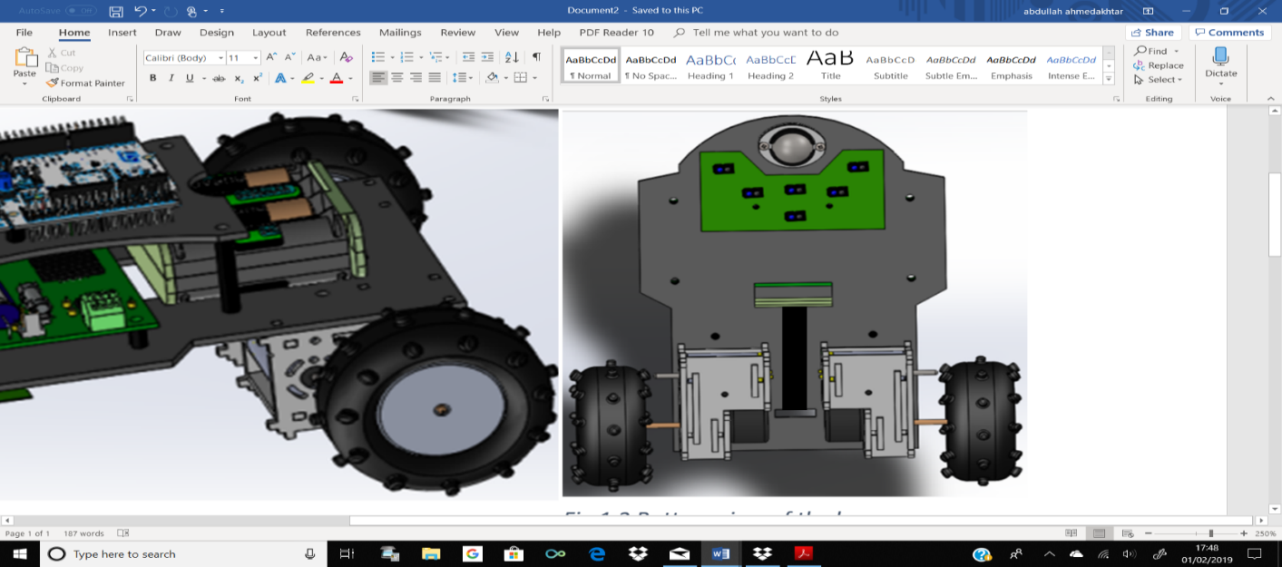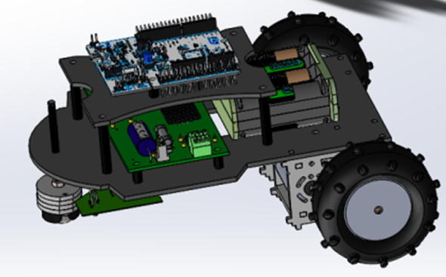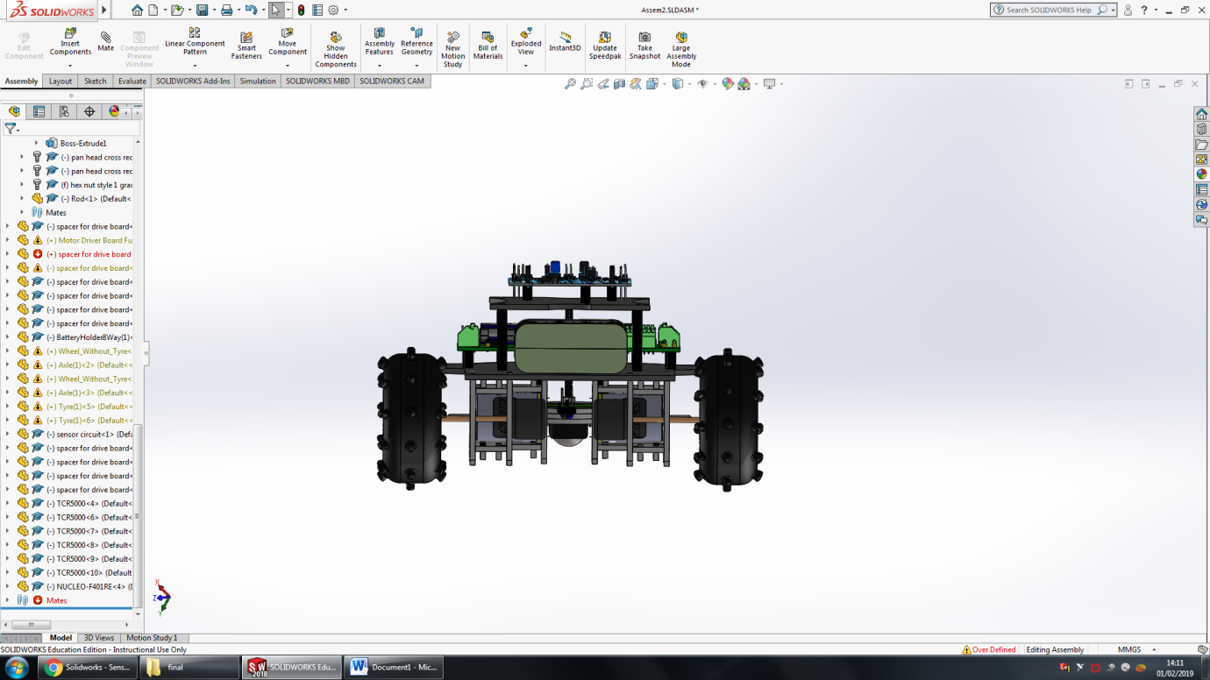Screenshots and brief description of the buggy design are given below.

Fig 1.2 Bottom view of buggy [1]

Fig 1.1 CAD of buggy [1]

As can be seen in fig 1.1, buggy design consists of two plates upper and lower. Upper plate only consists of the nucleo board and is connected to the lower plate using spacers, length of spacers is such that the gap between lower and upper plate is big enough to fit part of battery pack (shown in fig 1.1). Gearbox, sensor circuit and ball castor fit under lower plate, battery pack and motor drive board are on top of the lower plate as shown in fig 1.2 and 1.1 respectively. Two rectangular holes (large hole in the centre and small hole between gearboxes) have been cut in the lower plate shown in fig 1.2. Battery pack is placed between these holes and Velcro strip threads through the holes and around battery pack to secure it to the plate. The larger rectangular hole is also used for wires to go through from components under the plate to above e.g. wire from motor (under the plate) to the motor drive board (top of lower plate).

# Technical overview

## Motor characterisation [3]

The track used to test the buggy consists of slopes (ramp) of maximum height of 15°. For buggy to go up the ramp, it needs more torque, therefore a gearbox is required, which changes the torque and speed of the buggy depending on the situation e.g. going up the ramp or moving on flat surface.

Data collected from the load measurement experiment showed that the torque required to go up a ramp of inclination of 15° is 0.0786 Nm for a buggy of mass 1.25 Kg, however this was based on an early estimate of the buggy mass. Mass of the buggy decreased after it was decided to use ball castor instead of castor wheel and a more accurate mass of chassis plates was calculated using $mass=density*volume$. The new buggy mass is 1.10 Kg; therefore, the new wheel torque is 0.07981 Nm.

Without gearbox, the required current across the motor will be 9.938 A, however the motor drive board is only capable of supplying maximum current of 1.4 A to each motor. To avoid any risks, a safety margin is taken and is assumed maximum current is 1.12 A. Using 1.12 A, the calculated motor torque is 0.008 Nm. Using the two torque values, the calculated gear ratio is 9.975.

Based on this, the chosen gearbox is gearbox 2, which has gear ratio of 15, but efficiency is 72.25% therefore 10.84, as it provides a higher torque than the minimum required for the buggy to set off. Gearbox 2 will allow buggy to move at a faster speed than gearbox 3 and will provide higher torque than gearbox 1.

## Software System [4]

The software will be implemented on an STM32F401RE board. Because of this particular board, the potential software constraints can be 512 kB of flash storage, 96 kB of RAM and 84 MHz system clock. This signifies that the entire program size must not exceed 512 kB and the RAM can be a limiting factor to holding a number of sampled data while the control algorithm performs calculations on that data. An 84 MHz clock suggests that the sampling rate of the sensors will generally be a fraction of that and with a clock period of 0.0019 seconds, the precision of movements may be limited. The following abbreviations are members of the case diagram. These act as an abstract input and output sources. Some have both functionalities, such as using sensors (to switch on/off and perceive curves and track).

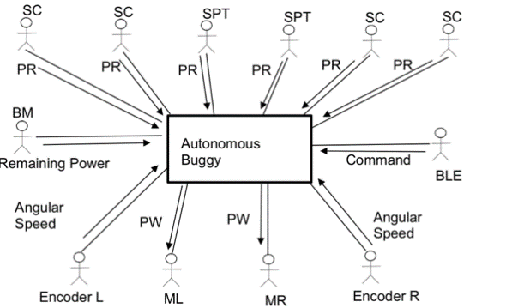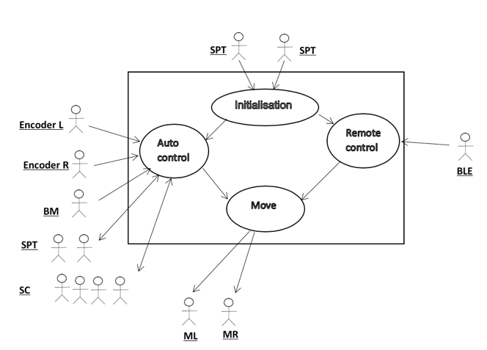

Figure 2.1 Messages exchanges between actors and system (see left) and Interaction between the external objects and the system (see right).

* SPT: Sensors for Perceiving the Track.
* SC: Sensors for Curving
* PRL: Position with respect to the line.
* PWM: Pulse wave modulation.
* M (R, L): Right Motor, Left Motor.
* BM: Battery Monitor
* BLE: Bluetooth Low Energy to make changes due to user remote input.

SC is made up of 4 separate sensors that follow curves. These are sensors 1,2,3 and 4 in figure 2.4. These sensors can be individually switched on and off in software to lower power consumption and effects of crosstalk. SPT are made up of 2 separate sensors 5 and 6 (in figure 2.4) that perceive the track and are for safety purposes where they inform the auto control algorithm to make immediate adjustments.

The following is an object specification of how the buggy performs according to the series of inputs and outputs.

WHILE NOT finished  
 Wait for detection of white line

While (detection of white line) { Input:

Position with respect to the line from SPTs

Position with respect to the line from SCs

Angular speed from Encoders  
 Check Command from BLE to override control algorithm

Remaining power from BM

Execute control algorithm

Output:  
 PWM to MR

PWM to ML

} ELSE Finished=TRUE

## Sensor Characterisation [4]



Figure ‎2.2 A graph comparing effective voltage difference of sensors at varying heights (see left) and line spread characteristics of the sensors (see right)

To choose a suitable sensor in terms of sensitivity to the track’s white line, noise rejection and power consumption, experiments were conducted on 5 different sensor combinations. Experiments with results shown in figure 2.2 measuring effect of variation of height while controlling distance to white line and ambient light and variation while controlling height to track show that TCRT5000 at 10,000 ohms exhibits the greatest noise rejection and sensitivity to line. The TCRT5000 was selected as the sensor of choice by the group due to the inbuilt crosstalk shield, smaller footprint, low latency and sensitivity to IR. This sensor was implemented on a digital sensor board using 2 quad comparators and a Darlington chip array to allow individual power on/off capabilities.

## Control Algorithms Selection [4]

While ‘bang-bang’s immediate switch on/off states can be useful in situations where abrupt turns occur, proportional allows a larger flexibility, allowing inter-state regions. Resulting in refined and smoother turns. The Proportional-Integral-Derivative controller adds specific functionalities that increase the accuracy of turn detection. The ‘proportional’ part allows the controller to maintain stability by decreasing current error under a steady state. The ‘integral’ part analyses previous errors and rejects random noise. ‘Derivative’ on the other hand has the ability to predict future errors.

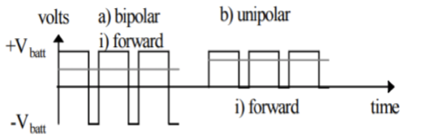

Figure ‎2.3 shows both unipolar and bipolar modes in forward direction.

The buggy will utilise a rear-wheel drive transmission with the variable speed motors acting as a pivot to allow the buggy to manoeuvre. The motors are powered and controlled by the motor drive board using the H-bridge circuit in uni-polar mode. Uni-polar is a superior to bipolar mode which allows huge reductions in power loss due to lower conduction losses. The fine control of the motors is performed in software.

There is also an important choice of developing algorithms using analogue or digital sensing. Typically, due to sampling limitations, digital sensing can operate at higher frequencies allowing faster responses to immediate changes. Analogue sensing can take longer sampling times as well as slowing the speed of PID controlling. Despite its complexity, the group has chosen to go with implementing a PID algorithm. The sensors have been designed as a specific configuration to maximise sensor resolution and provide extra safety features. Sensor 1 is placed at least 10 mm away from sensor 2, this is designed to account for breaks in the track. That means at any given point, either of the sensors will be detecting a white line, solving that issue physically, rather than developing exceptions in software.



Figure ‎2.4 Sensor implementation imagined over a straight line (see left) and over a maximum possible turning circle.

Using overlay techniques and trigonometric calculations, sensors 5 and 6 are placed 15 mm away from sensors 3 and 4. This design shows that even at the maximum angle of curvature of track, sensors 5 and 6 should not be triggered on. Acting as a safety feature, these sensors are able to detect if the buggy has overshot the track much earlier than using a single line sensor.

## Chassis design [4]

Firstly, the material chosen for chassis is Acetal, as it has low weight, cost and is easy to manufacture. Low weight of the chassis will reduce the overall weight of the buggy therefore will influence the speed and torque of the buggy when going up the ramp. Lighter the buggy lesser the torque required for it to go up the ramp and therefore it effects the gear ratio selection. Low cost is important as the overall budget of the project is 40 £, which must not be exceeded. Acetal is easy to manufacture and can be cut easily using laser cutter, which will be used by university to cut the material.

Secondly the shape and design of the buggy is important as It influences driving and handling of the buggy. To improve the control and handling of the buggy the size of the buggy must be small and compact and to achieve this, two plates for chassis are used instead of one large as shown in figure 1.1. This will improve the manoeuvrability of the buggy. Lengths of lower and upper plates are 21 cm and 11.4 cm respectively; maximum width of lower plate is 15 cm and upper plate is 9.1 cm wide. The shapes of two plates are in a way to reduce the waste of material which will also add unnecessary weight e.g. lower plate is 12 cm wide and is only 15 cm wide for area where motor drive board will fit.

The sensor circuit is placed before the castor ball as shown in fig 1.2, this will ensure that when buggy goes up the ramp the sensor circuit does not hit the ramp as castor ball will reach the ramp first and buggy will be on its way up by the time sensor circuit reaches the ramp. Components are placed on chassis so that the weight is evenly distributed to reduce the risk of buggy turning over.

## Winning features [4]

In order to win buggy must finish the race and in the quickest time. To ensure the buggy finishes race, it must stay on the white line. White line will be detected by sensors therefore sensor choice and implementation are very important.

As discussed above 6 TCRT5000 optical sensors will be used in a smiley face implementation as shown in fig 1.2. This implementation is used, as it will allow buggy to detect a turn in the track in more effective way than a straight-line implementation therefore reducing risk of buggy going off the track. Sunlight can affect the performance of the sensors and to deal with this, sensors will be covered using tape in order to reduce external influences on the sensors. Another option being considered is use of a variable resister to finely tweak the threshold of the sensors, to make them more or less sensitive on the day based on the conditions. The track will also have a break in white line of 6 mm, two vertically aligned sensors in the middle will deal with this as they are 1 cm apart therefore break of 6 mm gap will have no effect on the buggy.

Another point is the chassis design of the buggy is compact and small, which will decrease the overall weight of the buggy therefore the buggy will be able to reach faster speed consuming same amount of power compared to heavier buggies, therefore finishing the race in a quicker time.

# Team Organisation

It was agreed that the team will not assign a role to a single person, at least not specifically. Normally this can be seen as a drawback, but it increased the friendship between the colleagues. Freedom to choose what to do enhanced the effort that was put in everybody’s work. The leadership was shared between two people as well as the meetings’ organisation, the responsibility for redaction of the journals was rotating through everybody. All the members of the team have tried to share the same amount of responsibility.

The team used two applications for the main purpose of communication and file share. A WhatsApp group was created for messaging, as everyone has this app in their phones then there was no doubt that it will be the best way to communicate quickly and effectively, and it was named “ESP GROUP 22”.

As it can be seen below in Figure 3.2 the group was created by Osama Othman on September 24th of 2018 and it was used mainly to establish the days and time of the meeting as well as to answer some questions and/or take simple decisions.

In the same way, a Dropbox folder was created by Marlon Guanoluisa on October 6th of 2018 to share documents, tables and any other related information. Which can be found in the following link:

<https://www.dropbox.com/sh/u3l5d3g69wiv0qz/AABpm1Bbjad1x9BgkFe5X2Kwa?dl=0> .

For keeping an organised and clean place of sharing files, the following simple rules were set:

* Creation of different folders for each topic.
* Upload as soon as possible the work done.
* Check everyone’s documents.
* Create a new document followed by the corresponding version and save it in the same folder that was taken, if a modification was needed.
* Avoid uploading unnecessary content.
* Inform all members what was modified, if any.

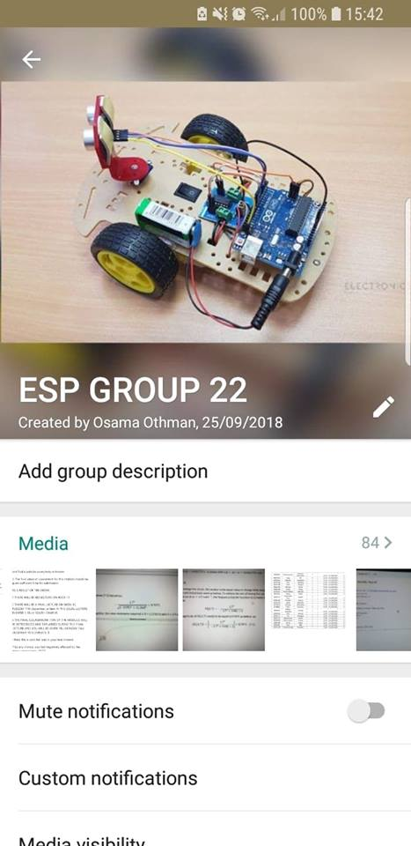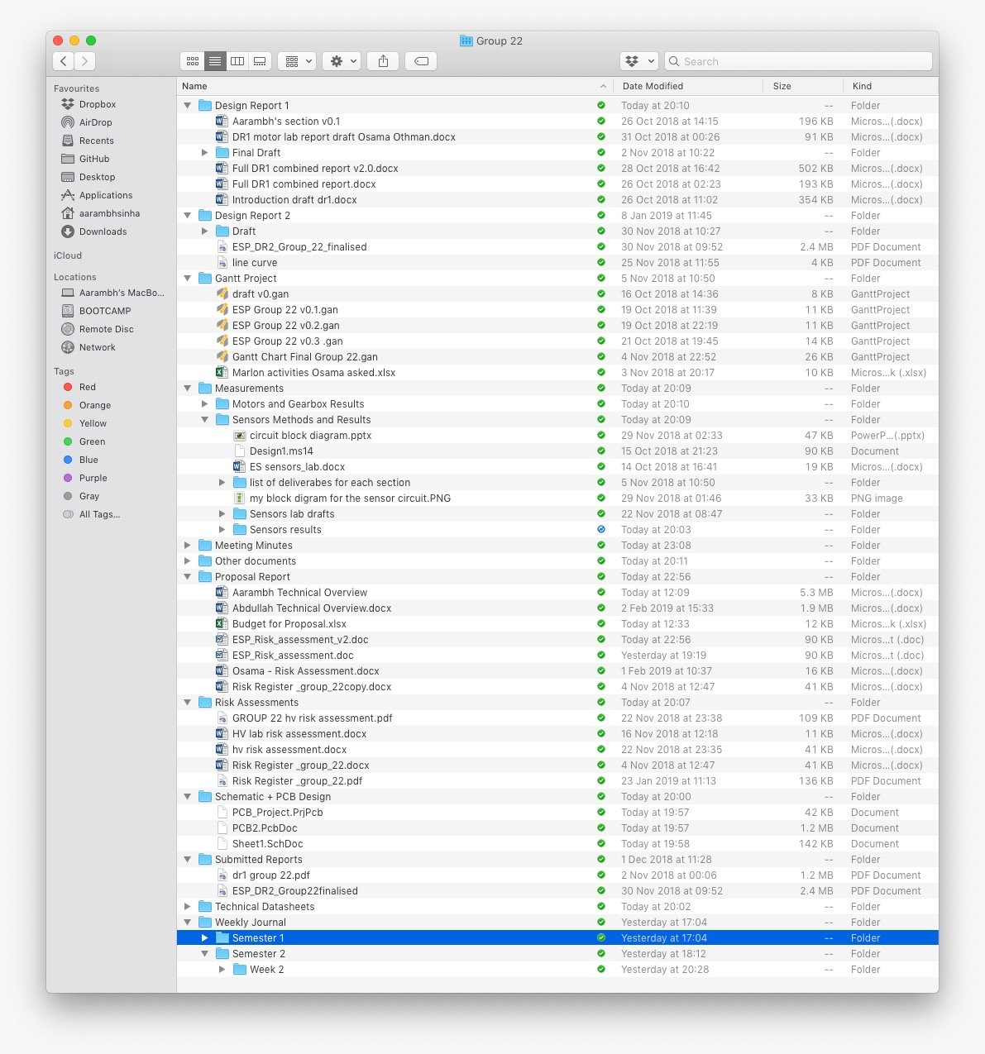

Figure 3.1 Shared folders on cloud servers(left). Figure 3.2 WhatsApp Icon(right)

As mentioned before, meetings were informed using the messaging platform WhatsApp and they were carried out at least twice a week. Every Monday after having been discussed with the tutor, the group met for one to two hours approximately on that day, Wednesday and/or Friday were the most usually days used for having another meeting depending on how busy or difficult it was the week. In Dropbox, the previous link, some pictures can be found containing the information discussed on those days in the folder called “Meeting minutes” that was also used as a guide for writing the weekly journal which as well can be found in the folder called “Weekly Journal”.

In a cooperative and relaxed environment, all members of the group were able to share their ideas and participated at the time of deciding. To take a decision, there was not usually any problem, and everybody agreed in one thing, whatever decision made it must be supported by at least 80% of the total number of members i.e. four people. It was encouraged to all colleagues to say any curiosity to make to everyone clear about what are the advantages and disadvantages of taking such decisions. Therefore, no regrets were carried and as well as no blames to anyone.

The work has been tried to be shared in an equal way. Although there is not a manner of giving to each one an exact amount of work, it was assured that everyone takes almost the same workload and even when any one of the members was able to finish his work earlier than expected, it was asked to this person to try and help to one of the colleagues that is struggling in doing the task entrusted. Of course, a plan was developed to do not lose the path of the project. Having a plan to follow makes easy for the group to carry out all tasks in an established time. To achieve this the application called “Gantt Chart” was used which it will be seen later in this document and structured for this semester. Considering the learning styles of each one and their individual skills it was concluded that Osama Othman and Subhi Alsous will be working on the software development and Abdullah Ahmed Akhtar, Marlon A. Guanoluisa Pozo and Aarambh Sinha will be focusing on circuit and hardware development. The meetings will continue having a place at least twice a week to check the progress of everyone as well as solving any issue related to the project.

# Planning and Budget

## Bill of materials of buggy

|  |  |  |  |
| --- | --- | --- | --- |
| Item category | Item Manu. Part | Quantity needed | Cost per component (£) |
| Free issued components | | | |
| Populated PCB | NUCLEO -F401RE | 1 | 15 |
|  | Controller board | 1 | 30 |
| Integrated Circuits | LM339 | 1 | 0.64 |
|  | ULN2003 | 1 | 0.23 |
| Unpopulated PCBs, IC Sockets and Headers | 8 pin IC base | 3 | 0.8 |

|  |  |  |  |
| --- | --- | --- | --- |
|  | 4 way SIL Header | 6 | 0.2 |
|  | Sensor Mini PCBs | 3 | 1 |
|  | Jumper cables | 1 bag | 3 |
| Sensors | TCRT5000 | 2 | 0.64 |
|  | AEAT-601BF06 | 2 | 16.85 |
|  | HM-10 | 1 | 16.36 |
| Mechanical Parts | Chassis | 1 | 42 |
|  | Front wheel | 1 | 2.5 |
|  | Rubber tyre | 2 | 1.45 |
|  | Motor B | 2 | 7.11 |
|  | Gear Box | 2 | 7 |
|  | Sensor PCB | 1 | 50 |
| Misc | Battery Holder | 1 | 3.5 |
|  | Cable ties | 3 | 0.2 |
|  | Batteries | 8 | 2 |
| Basic electronic parts | resistors | 12 | 0.1 |
|  | Var. resistor | 1 | 0.12 |
| Budgeted components | | | |
| Sensors | TCRT5000 | 4 | 0.64 |
| Unpopulated PCBs, IC Sockets and Headers | 8 pin IC base | 3 | 0.8 |
|  | 4 way SIL Header | 10 | 0.2 |
|  | Sensor Mini PCBs | 3 | 1 |
| Integrated circuits | LM339 | 1 | 0.64 |
| Total | | | 264.45 £ |

Table 1 showing the cost of components used to build the buggy

From Table 1, the total budget used was only 10.6 pounds out of the 40 pounds limit given, approximately 26.5%, concentrating on buying only the essential items. This is done so that if we need any more items such as more sensors to replace broken ones, we don’t exceed the budget. All items were chosen from [2].

|  |  |  |  |  |  |  |  |  |
| --- | --- | --- | --- | --- | --- | --- | --- | --- |
| **WORK ACTIVITY/**  **WORKPLACE**  **(WHAT PART OF THE ACTIVITY POSES RISK OF INJURY OR ILLNESS)** | **HAZARD (S)**  **(SOMETHING THAT COULD CAUSE HARM, ILLNESS OR INJURY)** | **LIKELY CONSEQUENCES**  **(WHAT WOULD BE THE RESULT OF THE HAZARD)** | **WHO OR WHAT IS AT RISK**  **(INCLUDE NUMBERS AND GROUPS)** | **EXISTING CONTROL MEASURES**  **IN USE**  **(WHAT PROTECTS PEOPLE FROM THESE HAZARDS)** | **WITH EXISTING CONTROLS** | | | |
| **SEVERITY** | **LIKELIHOOD** | **RISK RATING** | **RISK ACCEPTABLE** |
| **Lifting heavy objects, such as a buggy or moving test rigs.** | **Picking up objects without the correct technique can cause physical damages to the person.** | **Muscle damage and straining back muscles and joints.** | **Person that is lifting any object from a low height.** | **Give people guidance on how to pick up heavy objects or avoid having heavy objects being placed on the floor. Using the right technique ensure that you minimise the potential consequences.** | **2** | **2** | **4** | **Y** |
| **Moving around room of K3 gym to watch race or heat.** | **Tripping on objects such as bags and tools lying on the floor. Spillage from stranded bottles of water can cause slipping on a wet surface.** | **Cuts, bruises, breaks and/or sprains due to fall on hard surface.** | **Anyone moving around the room.** | **Remove any obstructions immediately when they become present and clean and dry any wet areas immediately when they become present. Before the race and Heat tests sweep the area for any obstructions and wet areas. Ensure there is adequate lighting in heat tests and race. Report to a qualified member of staff in charge of tests or race when there is damage to flooring in great hall room. Coordinate crowd to space out to ease movement through tight spaces. Small signs and barriers should be erected to coordinate people to wear they should watch** | **3** | **2** | **6** | **Y** |
| **Spending the entire day inside the Great hall if it’s a particularly warm or sunny day.** | **Extreme summer heats as race day is in the summer.** | **Heat Exhaustion: Symptoms are pale skin, excessive sweating, headache, nausea and vomiting, blurred vision and dizziness, with the potential for fainting.** | **Anyone watching race.** | **Turn off all heaters in room. Prepare ice cold water served on a spacious table and serve out the drinks. Open windows to let hot air out of room.** | **4** | **1** | **4** | **Y** |
| **Making last minute changes to the buggy or accidentally dropping it.** | **Fire, possible source maybe caused by a short circuit in an electrical circuit of buggy or lighting or sudden impacts to batteries.** | **Serious Injury, Death, major loss from fire.** | **Anyone present while watching or coordinating race or heat tests.** | **Coordinate the crowd in fire evacuation. Everyone present should be made aware of fire procedures by the announcers, especially emphasize that no batteries be left on floor with penalization to teams that do.** | **5** | **1** | **5** | **Y** |

TUOM_4COL**Assessment ID Number** (E&EE\_Initials\_DATE\_Number)**…ESP\_2018/19\_group 22 Activity Location: Great Hall**

|  |  |  |  |  |
| --- | --- | --- | --- | --- |
|  |  |  |  | **THIS RISK ASSESSMENT WILL BE SUBJECT TO A REVIEW NO LATER THAN: (MAX 12 MTHS)** |
| **MANAGER/SUPERVISOR** | **NAME: Zhirun Hu** | **SIGNED:** | **DATE:** |  |
| **Student:** | **NAME: Group 22** | **SIGNED:** | **DATE:** |  |

**IF THE ANSWERS TO ANY OF THE QUESTIONS BELOW IS YES THEN ADDITIONAL SPECIFIC RISK ASSESSMENTS MAY BE REQUIRED.**

|  |  |  |  |
| --- | --- | --- | --- |
| IS THERE A RISK OF FIRE? | Y/N | DOES THE ACTIVITY REQUIRE ANY HOME WORKING? | Y/N |
| ARE SUBSTANCES THAT ARE HAZARDOUS TO HEALTH USED? | Y/N | ARE THE EMPLOYEES REQUIRED TO WORK ALONE | Y/N |
| IS THERE MANUAL HANDLING INVOLVED? | Y/N | DOES THE ACTIVITY INVOLVE DRIVING | Y/N |
| IS PPE WORN OR REQUIRED TO BE WORN? | Y/N | DOES THE ACTIVITY REQUIRE WORK AT HEIGHT | Y/N |
| ARE DISPLAY SCREENS USED? | Y/N | DOES THE ACTIVITY INVOLVE FOREIGN TRAVEL | Y/N |
| IS THERE A SIGNIFICANT RISK TO YOUNG PERSONS? | Y/N | IS THERE A SIGNIFICANT RISK TO NEW / PREGNANT MOTHERS? | Y/N |

TUOM_4COL

***Severity value*** **= potential consequence of an incident/injury**

5 Very High Death / permanent incapacity / widespread loss

4 High Major Injury (Reportable Category) / Severe Incapacity / Serious Loss

3 Moderate Injury / illness of 3 days or more absence (reportable category) / Moderate loss

2 Slight Minor injury / illness – immediate First Aid only / slight loss

1 Negligible No injury or trivial injury / illness / loss

***Likelihood value* = what is the potential of an incident or injury occurring**

5 Almost certain to occur

4 Likely to occur

3 Quite possible to occur

2 Possible in current situation

1 Not likely to occur

***risk rating* = *severity value* × *likelihood value***

***risk ratings* are classified as *low* (1 – 5), *medium* (6 – 9) and *high* (10 – 25)**

**Risk Classification and Actions:**

**Rating Classification Action**

1 – 5 Low Tolerable risk - Monitor and Manage

6 – 9 Medium Review and introduce additional controls to mitigate to

“As Low As Reasonably Practicable” (ALARP)

10 – 25 High Stop work immediately and introduce further control measures

|  |  |  |  |  |  |  |
| --- | --- | --- | --- | --- | --- | --- |
|  |  | **SEVERITY** | | | | |
| **LIKELIHOOD** |  | **1** | **2** | **3** | **4** | **5** |
| **1** | **Low** | **Low** | **Low** | **Low** | **Low** |
| **2** | **Low** | **Low** | **Medium** | **Medium** | **High** |
| **3** | **Low** | **Medium** | **Medium** | **High** | **High** |
| **4** | **Low** | **Medium** | **High** | **High** | **High** |
| **5** | **Low** | **High** | **High** | **High** | **High** |

## Gantt Chart (Semester 2)

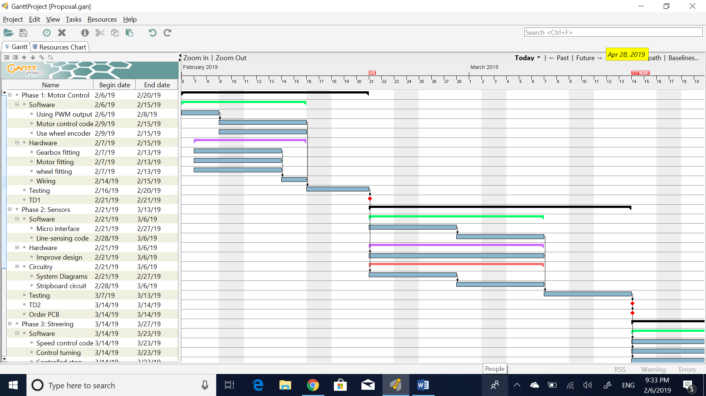

Figure 4.2 Phases 1 and 2 of Gantt chart

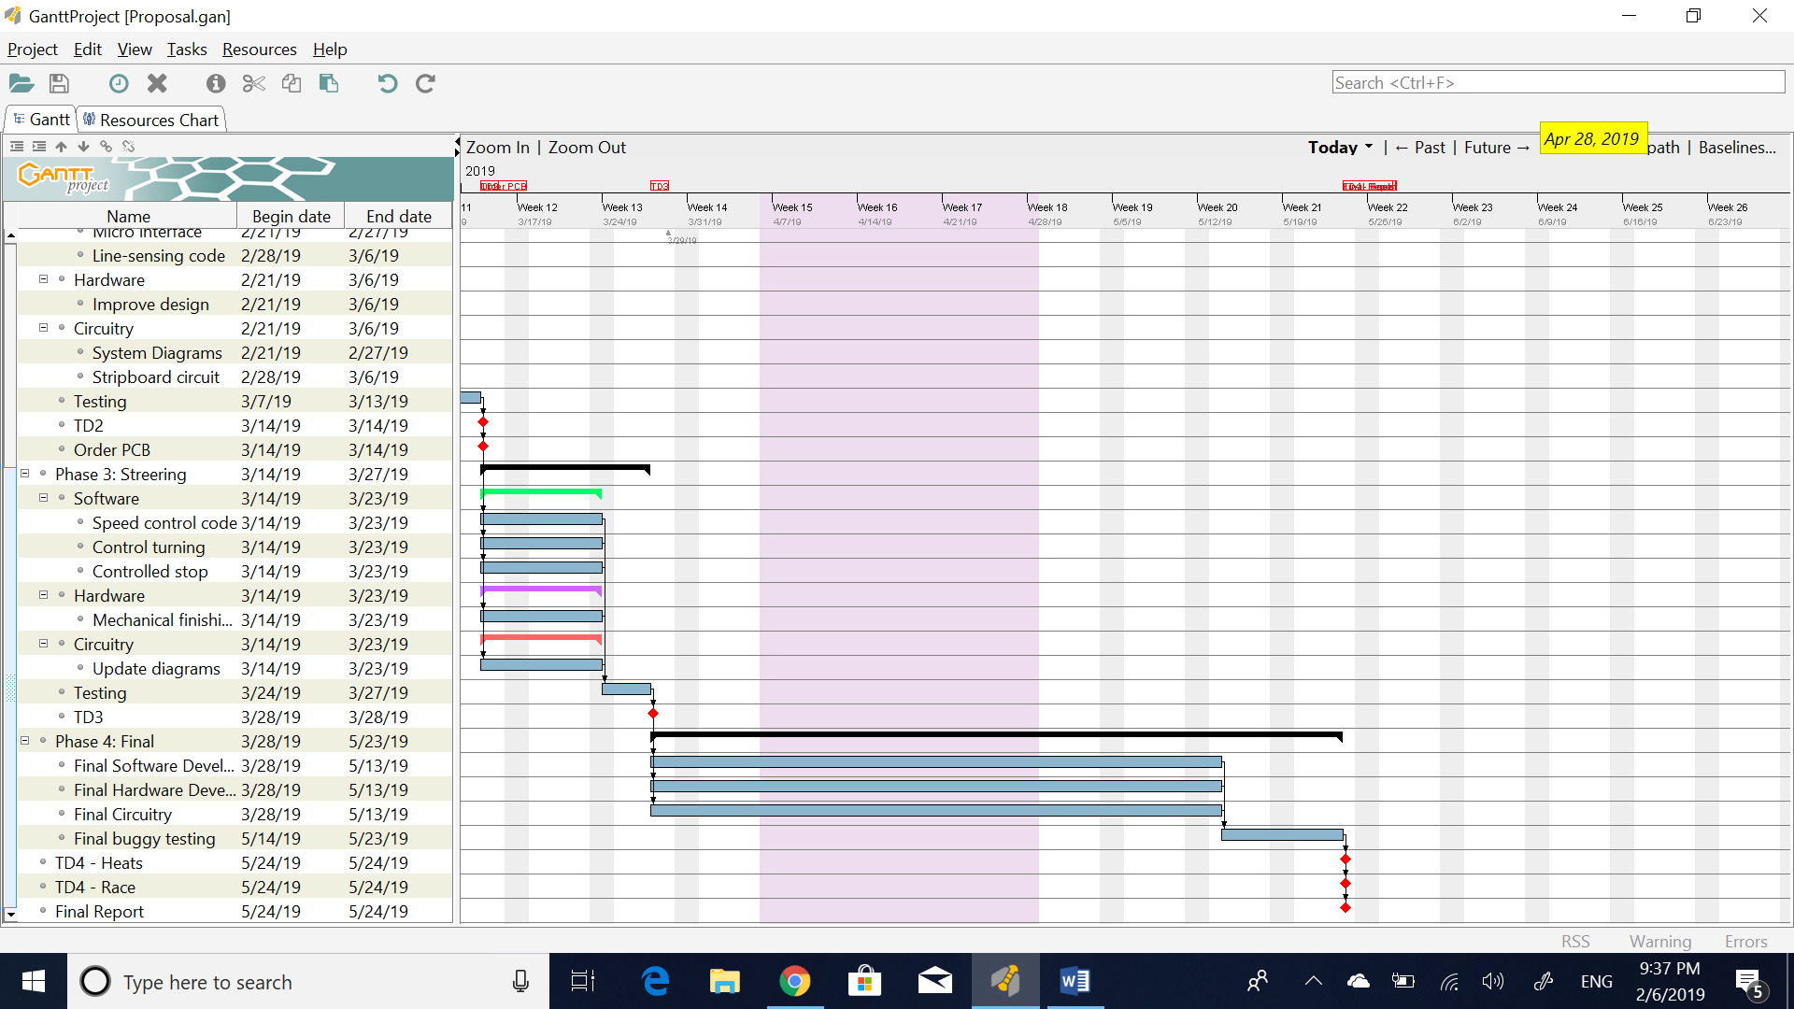

Figure 4.3 Phases 3 and 4 of Gantt chart

Semester 2 will be divided into four main phases and during each phase, within the team, 2 members will be responsible for the software development, 2 members responsible for the hardware development and one member responsible for the circuitry. However, all members will be kept updated constantly during the phases ensuring coherence between software, hardware and circuitry. Phase 1 is mainly motor control where the buggy components are initially mounted on the chassis with PWM control being developed simultaneously. Phase 2 depends on phase 1 where the sensing circuit is developed based on the success of the tests on phase 1. Ordering of the PCB and components is done before the deadline, during phase 2 after the stripboard sensor circuit satisfies the requirements. After Phase 2, Phase 3 initiates where the steering process is executed with the development of the controller required. The final phase is not executed until all first 3 phases are ended in which the complete buggy construction is finalised with the final program that can potentially finish the race successfully. To allow all system aspects to integrate, a testing section is included in each phase. The duration of the testing varies between 4 to 11 days depending on the phase. The testing also ensures contingencies are dealt with efficiently as the extra time offers enough room for error correction before the technical demonstration of each phase. Each technical demonstration must result in satisfaction to proceed with the project.

# References

[1] (version 2018). Solidworks: University of Manchester.

[2] Podd,F (2018-2019). ESP Procedures Handbook: University of Manchester. 37-38.

[3] S. Alsous, A. Akhtar, M. Pozo, O. Othman, A. Sinha, Design Report 1 – Motor Characterisation, 2018

[4] S. Alsous, A. Akhtar, M. Pozo, O. Othman, A. Sinha, Design Report 2 – Technical Characterisation, 2018